Chair’s Commentary on the School’s year

Each year, the Chair of Governors writes a commentary on what has been going on in the school for the past year. This is my commentary for the 2016-17 academic year.

Exams and achievement

As I always say, a school’s primary purpose is Teaching and Learning. I am therefore delighted to be able to report that our school continues to perform exceptionally well. A school like Gillotts is judged primarily on the basis of exam results at the end of Year 11. It has become more difficult to demonstrate the school’s success by comparing with previous years because, for a variety of reasons, the government is changing the measures at GCSE level. The conventional A* to G grades are migrating to 9 to 1 and the metrics by which schools are judged are moving to Progress 8 and Attainment 8. However, I think the graphic below, taken from the government’s school performance website, illustrates it pretty well.

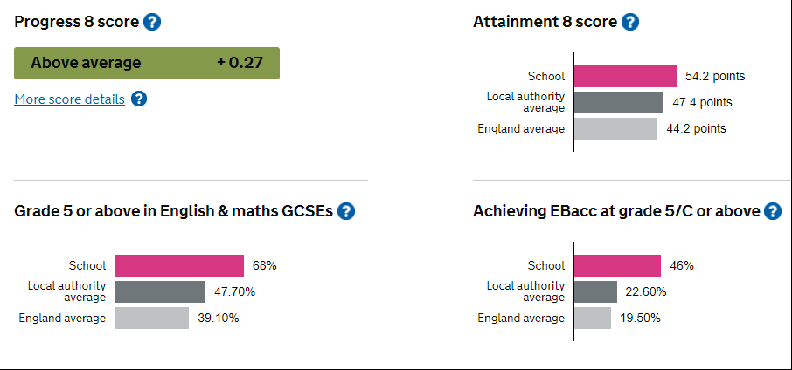
For more detail see https://www.compare-school-performance.service.gov.uk/school/137921

These results put us seventh among all the secondary schools in Oxfordshire in terms of our Progress 8 score (i.e. in the top 20%), third in terms of our Attainment 8 score and second in terms of students achieving Grade 5 or above in English and Maths.

These are excellent results, especially given the background against which they have been achieved. As many of you will be aware, education funding has been and remains under great pressure. Our Headteacher, along with others, has been arguing actively for schools to be better funded - some of you may have heard her on the Radio 4 last Saturday or seen her on television in recent weeks. The fact is however that real terms funding of the school has fallen significantly in recent years. The school’s leadership team and all the staff have contributed to minimising overall expenditure while continuing to maximise the resources devoted to teaching and learning. I think these results show that they have done an excellent job.

Most significant is that these excellent results are not an accident or a blip. They are part of a long-term trend achieved because of systematic and evidence-based teaching in the school. Inevitably, Year 11 cohorts vary and so do the results they obtain but overall, I am confident that the excellent performance of staff and Leadership Team will ensure the school continues to generate excellent outcomes for our students.

The built environment

As I mentioned above, we have sought to maximise the resources dedicated to Teaching and Learning in the school. Evidence shows that the most significant factors in determining outcomes for students are the quality of teaching and quality of feedback. This has been and remains our focus. However, maximising the resources dedicated to Teaching and Learning inevitably reduces the money available to be spent elsewhere. More than 80% of the school’s income is used to pay for staffing leaving relatively little for other needs. In terms of facilities, we have in recent years focused expenditure on those elements that are important to the functioning of the school. Much of the school is now about 60 years old and facilities such as heating and drains have needed work. It is also important to keep water and wind out of classrooms and above all, to ensure we provide a safe environment for our students. This obviously all makes sense but spending money in these ways leaves little over for other maintenance activities. As a consequence, the school is looking less good than it did three or four years ago.

As many of you who have been associated with the school for a while will know, we have a long-term plan for dealing with this…the school renovation project. Our goal is to sell a little used part of the school’s land and use the proceeds to build a new hall, dramatically improve the school’s sporting facilities and to renovate the rest of the school. Unfortunately carrying the plan through has proved far more complex than we envisaged when we started. For a whole range of reasons (which I will be happy to share with anyone with a couple of hours to spare), we have made little progress in the past year. While our commitment to the project is as great as ever, we still do not have a start date in which we can have confidence. For me this has been the biggest disappointment of the year.

A 21st Century School

We have continued to ensure that we take advantage of evolving technologies to benefit teaching and learning. During the last year, we have migrated from using printers to using multi-function devices (MFDs), accessible from any wireless device. All students are given a printing allowance appropriate to their stage in the school which they can increase on request at cost. Staff too have printing budgets. The effect of the change has been both to reduce printing costs and to dramatically reduce the hassle of getting stuff printed so it really has been a win-win innovation.

Another success has been the Bring Your Own Device programme that we introduced a couple of years ago. The school has ensured that devices support rather than hinder teaching and learning by using a traffic light system in lessons and study periods. Red means all devices put away, amber means they can be used for specific tasks and green means that general use is appropriate. In this way, the school ensures that students can benefit from the tremendous opportunities that devices offer without being distracted by them.

There is another element of allowing devices in school which I feel particularly strongly about. The school’s role is to provide an education for life. For Gillotts’ students, devices are an integral part of their lives. We have a responsibility to teach students how to use devices in positive ways and how to reject using them in negative ways. To do this without having them integrated into their time at school would be like teaching someone to drive in the classroom, then turning them loose on the road. And the consequences would be equally disastrous!

Looking Ahead

So how does the future look for our school? Well, overall, very bright. We have as good a team of staff and leaders as we could hope for. Financially, things are set to improve, at least a bit. It seems the government has, at least to some extent, heard the voices such as Catharine’s arguing that education should be regarded as an investment not an expense and made some concessions on school funding. We continue to look for and embrace opportunities to leverage 21st Century technology to optimise student outcomes. We are negotiating the transition ‘A* to G’ to ‘9 to 1, Progress 8 and Attainment 8’ and hopefully will be able to focus on teaching the new GCSEs for the next few years. The principal uncertainty is the timing of the school renovation project but we will persevere and I am sure we will succeed eventually! For my part, I remain immensely proud of the school, continually impressed by the effort and commitment shown by the people associated with it and very lucky to be Chair of Governors here.

Statutory Annual Report to parents on the effectiveness of arrangements for SEN and Disability

The school’s SEN Policy was last reviewed and amended by the Governors, Headteacher and SENCo in February 2015. Its aims and objectives are set out below.

Gillotts values the abilities and achievements of all its students and is committed to providing, for each student, the best possible environment for learning by:
- ensuring the identification of SEND as early as possible in students’ school careers
- monitoring progress
- working collaboratively with parents/carers and outside agencies
- involving students and parents in decision-making
- personalising learning for students
- promoting independence
- ensuring that the responsibility for SEND held by all staff and governors is carried out
- removing barriers to achievement and success

Students with SEN at Gillotts continue to make good progress in all areas of school-life: academic, social and emotional. There were 20 students on the SEN register in Year 11. Their attainment 8 score was 35.6 meaning that their average grade was 3.56 (measured on the new GCSE 9-1 scale). 10 of the students achieved grade 4s and above in both English and mathematics; 11 in English and 13 in mathematics.

Staff have continued to receive training and guidance throughout the year and SEND were at the heart of the School Development Plan, with a particular focus on literacy difficulties. Besides the regular staff briefings, the work of our SENCo has been supported by working in partnership with the SENCos of our five partner primary schools. SENCo panels took place six times during the year. A key aspect of our work is to give professionals time to reflect on their own practice and share successful classroom strategies with colleagues. This year’s main focus is to consolidate expertise and embed good practice in the classroom so that all teachers are effective teachers of SEND and consistently meet the needs of all students in the classroom.

While the implementation of the new SEN Code of Practice has been at the forefront of the Learning Support Faculty development plan over the past few years, the introduction of the new GCSE syllabuses and their implications for students with SEND are now a priority. As a consequence, the range of Literacy and Numeracy Interventions offered at KS3 and KS4 has significantly developed to reflect the demands and recently identified learning and teaching needs of the new syllabuses. The Faculty is also keen to develop its range of assistive technology; for example we have invested in reading pens to support students in GCSEs while still promoting their independence.

Gillotts’ admissions are managed by Oxfordshire County Council. As an Academy, we publish our Admissions arrangements each year; however our arrangements follow the current published LA admission rules for Years 7 to 11 at community and voluntary controlled secondary schools. A summary of the arrangements, including for pupils with disabilities, is published each year in our Prospectus. Our Accessibility Plan was reviewed and developed further in June 2015. Curriculum Access actions include a focus on differentiation. There are lunchtime clubs taking place most days in Learning Support, which support students in developing friendships and social skills in a safe environment. A proportion of staff briefings are used for small groups of teachers to meet with Learning Support Assistants to share strategies to meet an individual’s needs. To ensure good Information Access, the school continues to work closely with the LA support services. Our Accessibility Plan (premises), adopted in 2003, was fully implemented by August 2006 and has been reviewed to ensure it continues to meet current requirements.

Catharine Darnton David Gorsuch
Headteacher Chair of Governors

EQUALITY OBJECTIVES – Monitoring progress

 | Equality Objective | Success Criteria | December 2017 | December 2018 | December 2019 | December 2020
1. | Progress  To improve achievement for identified groups: (Ofsted 2016)  Disadvantaged students  Student with SEND | Within 12 months  Gaps with national non-disadvantaged narrowed  Within 2 years  Gaps with national non-disadvantaged removed and gaps with national non-SEND narrowed  After 4 years  Gaps with national non-disadvantaged removed and gaps with national non-SEND removed | A8 2016-17  Non-PP (nat) tbc  PP (Gillotts) 35.2  A8 2016-17  All (nat) 46.0  K (Gillotts) 36.1
2. | Diversity of the workforce  Analyse our data so we monitor changes the diversity of our workforce (eg age, gender, ethnicity)  Analyse our data on pay so we can monitor issues of pay equality, including the gender pay gap | Within 12 months  Analysis complete  Within 2 years  Analysis complete  After 4 years  Analysis complete | Male Female  22% 78%  EG Percentage  W-B 93  W-O 4  Black 0  Asian 1  Mixed 2  NR 1  Other 0  Age Percentage  <25 3  25-34 20  35-44 23  45-54 33  55-64 21  >65 1  Pay equality – see below

December 2017 – Pay equality
NB Calculated using FTE salaries

 | Teachers - Main |  | Teacher - Upper |  | Support staff
 | Number | Average salary | Number | Average salary | Number | Average salary
Male | 6 | £26,274 | 10 | £38.152 | 7 | £19.531
Female | 11 | £29,269 | 27 | £38,153 | 47 | £21,421

December 2017 – Analysis of managers by gender

 | Teachers – TLR holders |  | Support staff – designated line manager
 | Number | Average TLR | Number | Average salary
Male | 8 | £6,817 | 1 | Withheld
Female | 13 | £6,627 | 11 | £29,042

Note analysis of Leadership Team pay is not included due to small numbers and separate reporting in the school’s accounts

