Clarification of school uniform policy in relation to shoes

You may recall that we had some issues in September with students wearing black trainers to school. It has been long established at Gillotts that trainers are not part of our uniform. Unfortunately, a number of sport shoe manufacturers brought out black trainers over the summer, I suspect in the hope that they would somehow ‘get round’ this rule, which is also commonly in place across many schools.

A number of parents wrote to us to say that they had bought the sports shoes believing that they would be acceptable and that they could not have anticipated that we would see these sports shoes as trainers. We therefore decided to allow a number of styles on a temporary basis, pending a fuller review. This review has now been completed, involving both members of the Leadership Team and the Governing Body.

We will continue NOT to allow trainers to be worn, and this includes a number of styles that we have deemed to be minimally acceptable this year. In order to clarify the definition of a trainer, the guidance below will be added to our uniform rules and will be enforced from September 2017. The advance notice should ensure that all shoes purchased for the new school year will be compliant with the rules.

Thank you in advance for your support with this matter

Ms Catharine Darnton
Headteacher

Shoes

Black shoes, leather or leather-look, closed back and front (no trainers, boots, sandals, Velcro straps)

Further guidance

The pictures below are a guide to the range of acceptable styles.
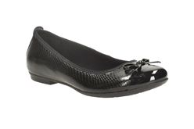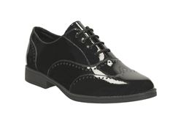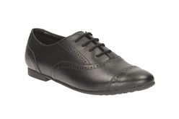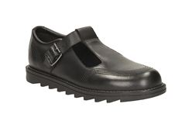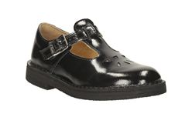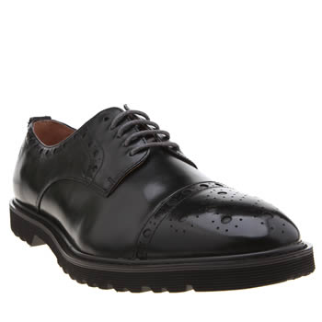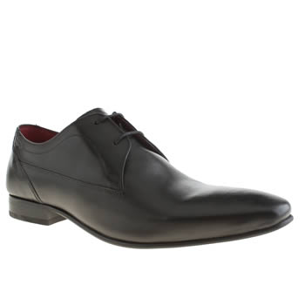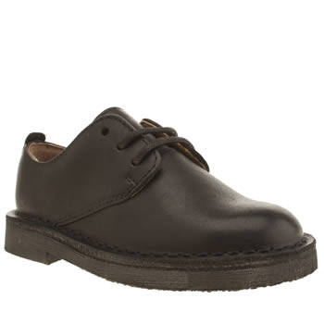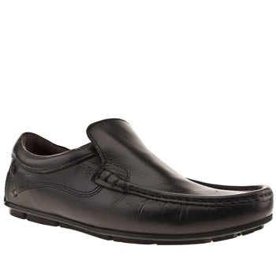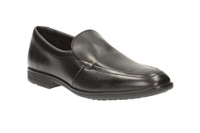

Please note trainers or trainer-style shoes are not acceptable, for example:
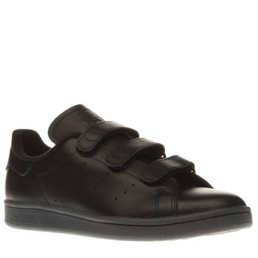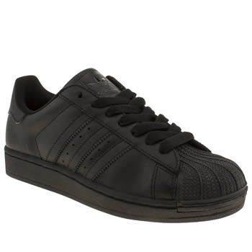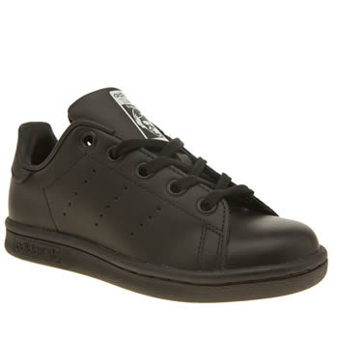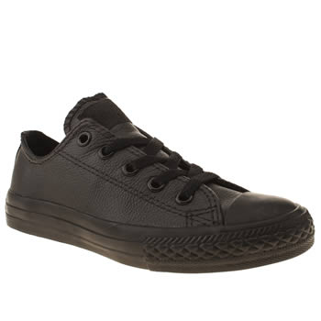
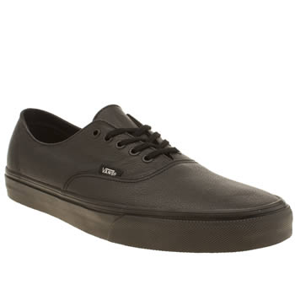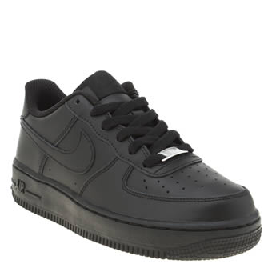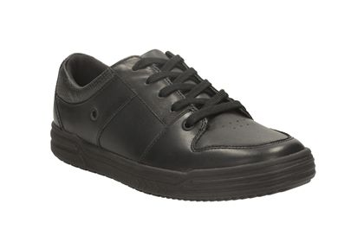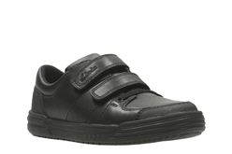

The Headteacher’s decision on matters of uniform is final.

