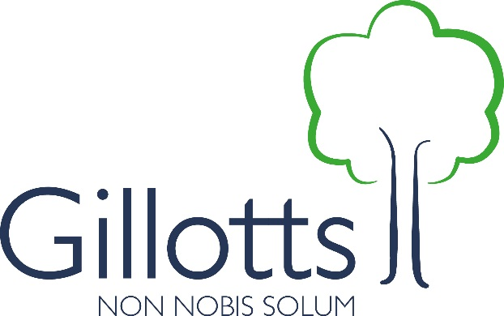
Help us to keep Gillotts great!

Our School Fund is an opportunity for parents to support the quality of education for their children through making regular voluntary contributions to be used directly to provide resources for use in the classroom and at home.

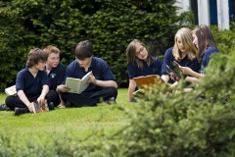

Why do we need your support?

Unlike many schools, Gillotts had not had a tradition of regular individual donations to support the school. However, as you will have seen from recent media coverage, the financial climate for all schools is becoming increasingly difficult. School funding has not been increased since 2010 in spite of steadily rising costs so in real terms, our income is falling. This is making it harder for the school to deliver the excellent teaching and learning we aspire to.

How much would we like you to contribute?

There is no obligation or pressure to donate but, if you would like to, we will be grateful for whatever you can afford. Suggestions donations are below.

If you give £10 per month, this would give us £120 per year – with Gift Aid, that is £150!

If you give £1 per day, this would give us £365 per year – with Gift Aid, that’s over £450 per year!

How does this work with the support provided by the Parents’ Association?

The Parents’ Association has provided invaluable support to Gillotts for many years – the photos on the back of this flier show you some of the items they have purchased for us. The Association is fully endorsing this request for individual regular contributions. However payments will be through the school, to preserve parents’ anonymity.

Ailsa Robinson, Chair of the PA says:
“The PA fully supports the school in striving to maintain a high standard of education for our children in the face of reduced income. Donating to the School Fund will be a way of trying to ensure that our children continue to receive the excellent standard of education that Gillotts at present provides. The School Fund is also a way for parents/ carers who do not have time to help with the PA to be involved with the school.”

What will we spend the funds on?

We will spend the funds on ensuring all curriculum subjects are well resourced, including with the additional new online resources (GCSE Pod, SAM Learning, Maths Watch etc) that we know students and their parents value so much. This will enable us to support students to continue to make the outstanding progress that has become the norm in recent years.

Please give whatever you can – fill in and return the form attached – thank you for your support.

Ms Catharine Darnton, Headteacher

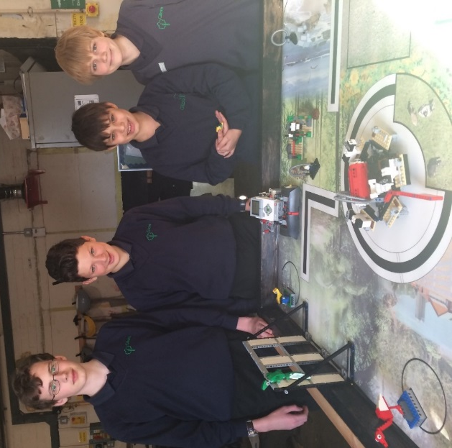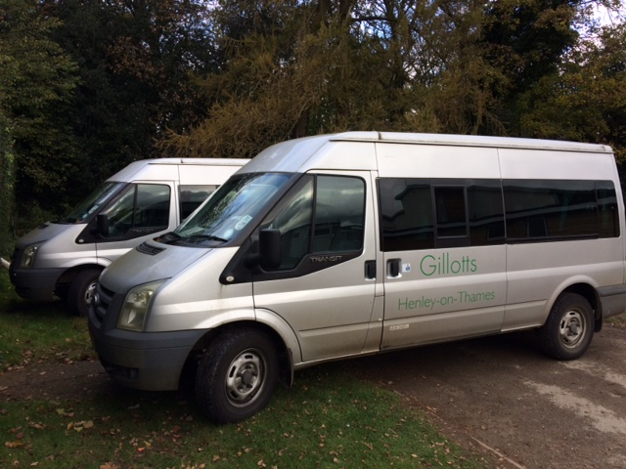

GILLOTTS SCHOOL FUND DONATION FORM

Please complete and return the forms below so we can reclaim Gift Aid from HMRC and use the standing
order mandate to set up a regular monthly payment to our School Fund. Please print these off as separate documents (not back to back) and return as hard copies marked for the attention of Student Services at the school.

Gift Aid  Gift aid boosts your donation by 25p for every £1 you donate. |  |  |  | I would like to Gift Aid all future donations to Gillotts School  (please tick box)
Gift Aid can be reclaimed by us from the tax you pay for the current tax year. Your address is needed to identify you as a UK taxpayer.

I confirm I have paid or will pay an amount of Income Tax and/or Capital Gains Tax for the current tax year (6 April to 5 April) that is at least equal to the amount of tax that all the charities and Community Amateur Sports Clubs (CASCs) that I donate to will reclaim on my gifts for the current tax year. I understand that other taxes such as VAT and Council Tax do not qualify. I understand the charity will reclaim 25p of tax on every £1 that I have given.

I want to Gift Aid any donations I make in the future or have made in the past four year to Gillotts School.

Signature |  | Date

Please notify us if you:
- Want to cancel this declaration
- Change your name or home address
- No longer pay sufficient tax on your income and/or capital gains.

If you pay Income Tax at the higher or additional rate and want to receive the additional tax relief due to you, you must include all your Gift Aid donations on your Self Assessment tax return or ask HM Revenue and Customs to adjust your tax code.

Donor’s details
Title
Forename(s)
Surname
Address – Line 1
Address – Line 2
Address - Town
Postcode
Email

Name(s) of child/children

Standing Order mandate
To the Manager of (your bank)
Address
(it is essential we have the full address as we will send the form to your bank).

Postcode
Please pay | Lloyds bank plc
Account name | Gillotts School Fund account
Sort code | 30 80 54
Account number | 19230968
The sum of:
Amount in words:
First payment date:
And thereafter on the same day of the month for: | years  OR  Until further notice  (please complete/delete as applicable)
My bank sort code
My account number
My account name
Signature
Date
Please quote reference | (to be completed by Gillotts)

Please return this form to Student Services at Gillotts School so we can add a reference number before sending on to your bank.

If you have any queries, please email Glynis Smith, Business Manager, gsmith@gillotts.org.uk in the first instance.

Thank you for supporting Gillotts School

Gillotts School is a registered company limited by guarantee * Company registration number 07954417 * Registered address: Gillotts Lane, Henley-on-Thames, Oxon RG9 1PS

